Membership Report to the CCDS 2020 National Convention

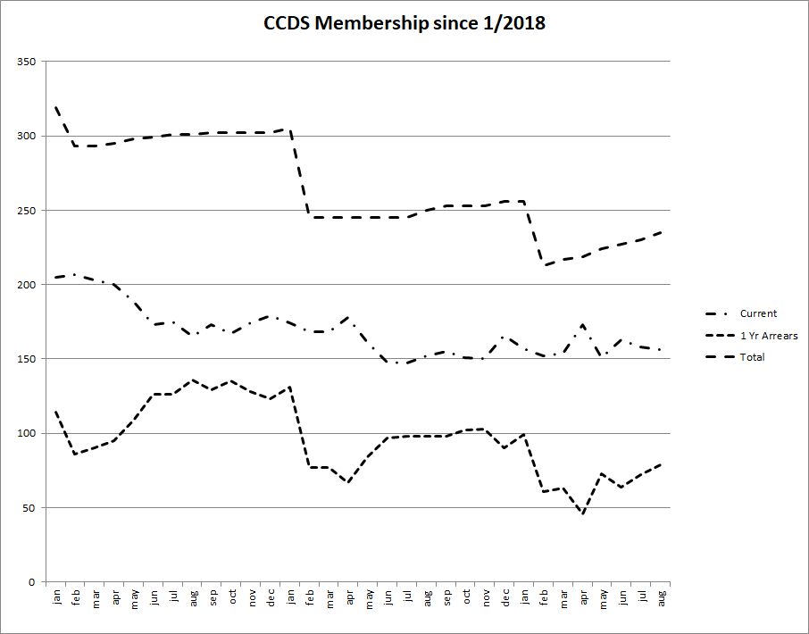

Traditionally CCDS has evaluated its membership based on the number of members who are current in their dues and the number who are no more than 1 year in arrears in their dues. Typically folks move back and forth between these two categories. The graph above shows those number since the start of 2018 – the top line is the sum of those two numbers.
Originally, CCDS handled membership based on the calendar year, so everyone’s membership retired at the end of December. Many years ago we changed that, so a membership expires one year after the last dues payment. However, our membership data still has an echo of that former policy -- there is a drop in overall membership at the beginning of each year.
As of the end of July 2020, we had 156 current members and 79 members no more than 1 year in arrears, for a total of 235.
Submitted 8/12/2020, by Steve Willett

